**Kubernetes:**

Kubernetes is an open-source container orchestration platform designed to automate the deployment, scaling, and management of containerized applications. It was originally developed by Google and is now maintained by the Cloud Native Computing Foundation (**CNCF**). Kubernetes provides a robust and extensible platform for managing containerized workloads and services. Kubernetes clusters can manage a large number of containers across multiple hosts, providing mechanisms for application deployment, maintenance, and scaling.

* **Meaning of Orchestration:** In the context of computing and software, "**orchestration**" refers to the automated arrangement, coordination, and management of complex tasks and processes. It involves the organization and coordination of various components, services, or systems to achieve a specific objective efficiently and consistently. Orchestration is often used in the context of managing distributed systems and applications, where multiple elements need to work together seamlessly.
  + **Example: Kubernetes Orchestration**

Imagine you have a web application consisting of multiple microservices (e.g., user service, product service, and order service), each running in its own container. Manually managing these containers would be complex and error-prone. Kubernetes orchestrates these containers by automating deployment, scaling, and operations, ensuring they work together seamlessly.

1. **Deployment:** Kubernetes can deploy your application across multiple containers and hosts, ensuring that the necessary components are running.
2. **Scaling:** If traffic increases, Kubernetes can automatically scale up the number of containers to handle the load.
3. **Self-Healing:** If a container crashes, Kubernetes will restart it, maintaining the desired state of the application.

* **Key Features of Kubernetes:** 
  + **Automated Rollouts and Rollbacks:** 
    - **Kubernetes** can automate the deployment of new versions of applications. If something goes wrong, it can roll back to the previous version automatically.
    - **Example:** Deploying a new version of a web service without downtime. If the new version has issues, Kubernetes can revert to the stable version.
  + **Service Discovery and Load Balancing:** 
    - **Kubernetes** automatically exposes containers using DNS names or their IP addresses. It can load balance traffic across containers.
    - **Example:** Exposing a frontend service so that users can access it via a stable DNS name, with traffic distributed across multiple instances.
  + **Storage Orchestration:** 
    - **Kubernetes** can automatically mount the storage system of your choice, whether from local storage, public cloud providers, or networked storage systems.
    - **Example:** Attaching persistent storage to a database container, ensuring data is retained even if the container restarts.
  + **Secret and Configuration Management:** 
    - **Kubernetes** can manage sensitive information such as passwords, OAuth tokens, and SSH keys. Configuration details can be stored separately from the application code.
    - **Example:** Storing and injecting database credentials into an application container securely.
  + **Horizontal Scaling:** 
    - **Kubernetes** can automatically scale applications up or down based on demand. This includes adding more instances of a container or reducing them when not needed.
    - **Example:** Scaling the number of instances of a web server during peak hours and reducing them during low traffic periods.
* **Some Key Concepts:** 
  + **Auto Healing in Kubernetes:**

**Auto Healing** refers to the ability of Kubernetes to automatically detect and correct problems to maintain the desired state of the application.

* + - **Example:** 
      * A container running a microservices crashes.
      * Kubernetes detects the failure and automatically restarts the container.
      * If a node (physical or virtual machine) fails, Kubernetes reschedules the affected containers to other healthy nodes in the cluster.
  + **Auto Scaling in Kubernetes:**

**Auto Scaling** includes both horizontal and vertical scaling of applications based on metrics and policies.

* + - **Example:** 
      * **Horizontal Pod Autoscaler (HPA):** Automatically adjusts the number of pods in a deployment based on observed CPU utilization or other select metrics.
      * **Scenario**: During a high traffic event, the HPA increases the number of web server pods to handle the load. When traffic decreases, it scales down the pods to save resources.
  + **Enterprise Support in Kubernetes:**

**Enterprise Support** involves features and services provided to ensure Kubernetes clusters are production-ready and supported in large-scale, mission-critical environments.

* **Example:** 
  + **Security:** Role-based access control (RBAC) to ensure secure access to cluster resources.
  + **Compliance:** Tools and integrations to meet regulatory requirements (e.g., logging, monitoring, and auditing).
  + **Managed Services:** Enterprise-grade managed Kubernetes services provided by cloud vendors like Google Kubernetes Engine (GKE), Amazon EKS, or Azure AKS, offering support, automated upgrades, and security patches.

**Why Kubernetes different from Container:**

Kubernetes and containers are related but serve different purposes in the world of modern application deployment and management. **Let's clarify their distinctions:**

* **Containers:**
* **Isolation:** Containers are lightweight, portable, and provide process isolation. They encapsulate an application and its dependencies, ensuring consistency across different environments.
* **Resource Efficiency:** Containers share the host operating system's kernel and resources, making them more resource-efficient than traditional virtual machines. They can be started and stopped quickly.
* **Packaging:** Containers package applications and their dependencies into a single unit. This packaging makes it easy to distribute and deploy applications consistently, regardless of the underlying infrastructure.
* **Docker:** Docker is a widely used platform for creating, managing, and running containers. It provides tools for building container images, managing containers, and orchestrating containerized applications.
* **Kubernetes:**
* **Orchestration:** Kubernetes is a container orchestration platform. It automates the deployment, scaling, and management of containerized applications. It focuses on coordinating multiple containers to work together seamlessly.
* **Scaling:** Kubernetes provides mechanisms for scaling applications horizontally by adding or removing instances of containers. It ensures that applications can handle varying levels of demand.
* **Service Discovery:** Kubernetes offers built-in service discovery, allowing containers to communicate with each other within a cluster. It provides networking solutions to ensure that containers can find and communicate with one another.
* **Load Balancing:** Kubernetes includes load balancing to distribute incoming network traffic across multiple instances of a containerized application. This helps in optimizing resource usage and ensuring high availability.
* **Rolling Updates:** Kubernetes supports rolling updates, allowing applications to be updated without downtime. It ensures a smooth transition from one version of an application to another.
* **Resource Management:** Kubernetes manages the allocation and optimization of computing resources for containerized applications. It allows resource constraints to be defined, ensuring fair resource distribution.
* **Cluster Management:** Kubernetes organizes containers into clusters, consisting of a master node and worker nodes. The master node manages the overall state of the cluster and makes decisions to achieve the desired state.

In summary, containers provide a standardized and portable unit for packaging and distributing applications, while Kubernetes focuses on orchestrating and managing the deployment, scaling, and operation of containerized applications. Kubernetes abstracts away the complexities of managing containers at scale, providing a comprehensive platform for building, deploying, and managing modern, distributed applications.

**Difference between Docker and Kubernetes:**

The differences are:

* **Purpose:**
  + **Docker:** Primarily focuses on containerization, enabling developers to create, package, and distribute applications along with their dependencies in isolated environments.
  + **Kubernetes:** Primarily focuses on container orchestration, automating the deployment, scaling, and management of containerized applications, ensuring they run seamlessly in production.
* **Abstraction:**
  + **Docker:** Provides a container runtime and tools for building and managing containers. It is more focused on the development and packaging aspects.
  + **Kubernetes:** Provides a platform for orchestrating and managing containerized applications at scale. It abstracts away the complexities of managing containers in a distributed environment.
* **Scaling:**
  + **Docker:** Provides basic scaling features, but doesn't inherently offer advanced orchestration for large-scale deployments.
  + **Kubernetes:** Offers robust scaling features, allowing automatic scaling based on demand, ensuring applications can handle varying workloads.
* **Service Discovery:**
  + **Docker:** Lacks built-in service discovery and load balancing features.
  + **Kubernetes:** Includes built-in service discovery and load balancing mechanisms, ensuring containers can find and communicate with each other.
* **Rolling Updates:**
  + **Docker:** Rolling updates need to be managed manually.
  + **Kubernetes:** Supports automated rolling updates, allowing applications to be updated without downtime.
* **Resource Management:**
  + **Docker:** Provides basic resource management features.
  + **Kubernetes:** Offers advanced resource management, allowing users to set resource constraints for containers and efficiently allocate resources across the cluster.
* **Cluster Management:**
  + **Docker:** Doesn't inherently provide tools for managing and orchestrating clusters of containers.
  + **Kubernetes:** Organizes containers into clusters, consisting of a master node and worker nodes. Manages the overall state of the cluster and ensures the desired state is maintained.
* **Networking:**
  + **Docker:** Networking is more basic, and manual configuration may be required for communication between containers.
  + **Kubernetes:** Provides a sophisticated networking model with a network overlay, allowing containers to communicate seamlessly across nodes.
* **Ecosystem:**
  + **Docker:** Has a broader focus on the containerization ecosystem, including tools for building, packaging, and distributing containers.
  + **Kubernetes:** Specifically designed for container orchestration, with a rich set of features and APIs for managing complex applications in production.

In essence, Docker and Kubernetes serve different roles in the container ecosystem, with Docker providing containerization tools and Kubernetes focusing on orchestrating and managing containerized applications at scale. They are often used together, with Docker providing the runtime for containers and Kubernetes handling orchestration and cluster management.

**Why Kubernetes is called cluster:**

The term **"cluster"** in the context of Kubernetes refers to a group of interconnected computers or nodes that work together to perform a specific task or set of tasks. In the case of Kubernetes, a cluster is a collection of nodes that collectively run containerized applications and provide the necessary infrastructure for deploying, managing, and scaling those applications.

**“Node”** **means:** In Kubernetes, a "**node**" refers to an individual machine (physical or virtual) that is part of a cluster. Each node plays a specific role in the cluster and contributes resources to run containerized applications. There are two primary types of nodes in a Kubernetes cluster: **“Master Node”** and **“Worker Node”**.

In summary, the term "**cluster**" in Kubernetes reflects the idea of a unified and collaborative group of nodes that work together to create a robust and scalable platform for deploying and managing containerized applications. The cluster architecture is a fundamental concept in Kubernetes that enables the platform to efficiently handle the complexities of modern, distributed computing.

**Architecture of Kubernetes.**

The architecture of Kubernetes is designed to provide a scalable and extensible platform for orchestrating containerized applications. It consists of several components that are distributed across nodes in a cluster.

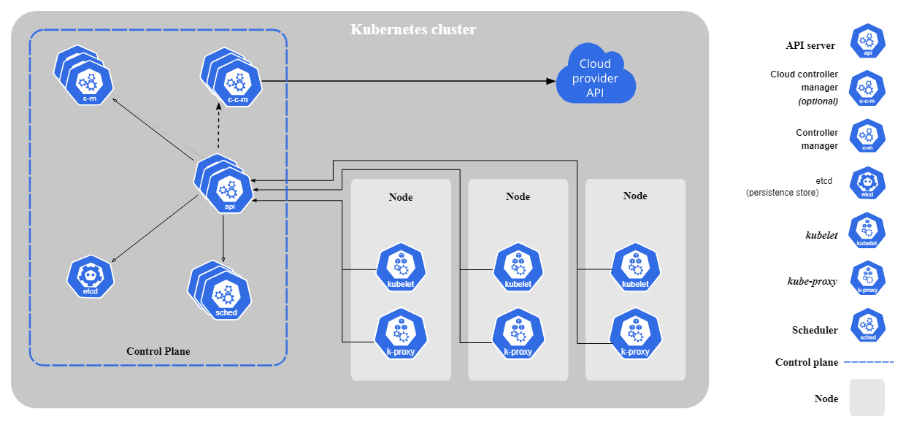

* **Here's an overview of the key components and their roles in the Kubernetes architecture:**

1. **Master Node (Control Panel’s):**

The master node in Kubernetes is responsible for managing the overall state of the cluster and coordinating the activities of worker nodes.

**Here are five key roles and responsibilities of the master node:**

* **API Server (kube-apiserver):** The master node hosts the Kubernetes API server, which serves as the primary endpoint for **cluster management**.It exposes the Kubernetes API, allowing users, administrators, and other components to interact with the cluster. The API server validates and processes requests, ensuring the integrity and security of cluster operations (It helps to expose the kubernetes to external world).
  + **Role:**
    - Acts as the central management point of the Kubernetes control plane.
    - Serves the Kubernetes API, which is the entry point for all administrative tasks.
    - Validates and configures data for the API objects (e.g., pods, services, deployments).
  + **Functions:** 
    - Handles RESTful API requests and updates the state of objects in etcd.
    - Provides endpoints for interaction with the cluster.
    - Ensures all components communicate through the API server.
* **Cluster State Management (etcd):** The master node uses etcd, a distributed key-value store, to maintain the persistent state of the cluster. etcd stores configuration data, metadata about pods, services, nodes, and more. It serves as the source of truth for the cluster, ensuring consistency and reliability in maintaining the desired state.
  + **Role:**
    - Acts as the key-value store for all cluster data.
    - Stores the state and configuration of the cluster.
  + **Functions:** 
    - Maintains the cluster state, configurations, secrets, and other metadata.
    - Provides high availability and consistency through distributed consensus (Raft protocol).
* **Scheduling (kube-scheduler):** The kube-scheduler component runs on the master node and is responsible for making decisions about where to place newly created pods. It considers factors such as resource requirements, affinity, anti-affinity, and node constraints to schedule pods on suitable worker nodes. The scheduler helps distribute workloads evenly across the cluster.
  + **Role:**
    - Assigns nodes to newly created pods based on resource requirements and constraints.
  + **Functions:** 
    - Watches for unscheduled pods and selects nodes for them to run on.
    - Considers various factors like resource availability, affinity/anti-affinity rules, data locality, and more.
* **Controller Management (kube-controller-manager):** The kube-controller-manager runs on the master node and manages various controllers, each responsible for maintaining the desired state of specific aspects of the system. Examples of controllers include the node controller, replication controller, endpoint controller, and more. Controllers continuously monitor the state of the cluster and take corrective actions to align the actual state with the desired state.
  + **Role:**
    - Runs various controllers that regulate the state of the cluster.
  + **Functions:** 
    - Includes different controllers such as the Node Controller, Replication Controller, Endpoints Controller, and Service Account & Token Controllers.
    - Ensures the actual state matches the desired state specified in the configuration.
* **Cloud Controller Manager:** In cloud environments, the master node may include the Cloud Controller Manager, which integrates with cloud-specific APIs. This component manages resources provided by the cloud provider, such as load balancers, storage volumes, and node instances. The Cloud Controller Manager extends the functionality of the Kubernetes control plane to interact seamlessly with the underlying cloud infrastructure.
  + **Role:**
    - Manages cloud-specific control logic.
  + **Functions:** 
    - Integrates with cloud service providers (e.g., AWS, GCP, Azure) to manage cloud resources.
    - Includes controllers like Node Controller, Route Controller, Service Controller, and Volume Controller that interact with cloud provider APIs.

In summary, the master node in Kubernetes plays a crucial role in coordinating and managing the cluster. It exposes the API, maintains the cluster state, makes intelligent decisions about scheduling, and oversees controllers to ensure the overall health and functionality of the containerized applications running on the worker nodes.

Kubelet

Kube-Proxy

Container Runtime

Pod-1

Pod-2

**Worker Node 1**

Master Node 1

API Server

Kube Scheduler

ETCD

Controller Manager

Cloud Controller Manager

C-1

C-2

Container

**UI**

**User Interface**

Pod-1

Pod-2

**Worker Node 2**

Kubelet

Kube-Proxy

Container Runtime

**CLI**

C-1

C-2

Container

**Kubectl**

1. **Worker Node (Data Panel’s):**

Worker nodes in Kubernetes are responsible for running the actual containerized workloads and executing tasks assigned by the master node.

**Here are three key roles and responsibilities of the worker node:**

* **Container Runtime:** The worker node hosts a container runtime, such as Docker or containerd, responsible for executing and managing containers. It interacts with the underlying operating system to start, stop, and manage containerized applications within pods.

* **Kubelet:** The kubelet is responsible for running your pods or responsible for maintaining the pods. If pod is running or not, if the pod is not running then fixed the issue (Because kubernetes has a feature called **auto healing,** I have to inform the kubernetes that the pod is not running, do something). Therefore, kubelet is basically responsible for ensuring the pod is always running. If the pod is not running then kubelet inform the API Server that something is wrong in pod, let’s restart or do something else.
  + **Roles:** 
    - Acts as the primary "node agent" that runs on each worker node.
  + **Functions:** 
    - Ensures that containers are running in a pod by communicating with the container runtime.
    - Continuously monitors the state of the pods and reports to the API server.
    - Executes instructions from the master node (e.g., starting or stopping containers).
* **Kube-Proxy:** Kube-proxy runs on each worker node and maintains network rules, facilitating communication to and from the pods. It enables network communication within the cluster, handles load balancing across pod instances, and ensures that network traffic is correctly directed to the appropriate containers.
  + **Roles:**
    - Manages network routing for the worker node.
  + **Functions:** 
    - Maintains network rules on nodes to ensure proper routing of traffic to containers.
    - Implements Kubernetes Service concepts like ClusterIP, NodePort, and LoadBalancer.
    - Uses iptables or IPVS to manage networking and ensure efficient communication between services.

These responsibilities make the worker node the execution environment for containers and the primary point of interaction between the Kubernetes control plane and the containerized applications. Worker nodes collectively contribute resources to the cluster, and their proper functioning is crucial for the overall health and performance of the Kubernetes cluster.

**Why Kubernetes called “K8s”:**

The term "**K8s**" is a shorthand representation of "**Kubernetes**," where the number "**8**" represents the eight letters between "**K**" and "**s**". This abbreviated form is a common convention used to make it easier and quicker to refer to Kubernetes in written and spoken communication, especially in contexts where brevity is desired, such as in command-line interfaces, scripts, and other informal settings.

**“Pod” in Kubernetes:**

In Kubernetes, a "**Pod**" is the smallest deployable unit and the basic building block of the deployment model. A Pod represents a group of one or more containers that are deployed together on the same host and share the same network namespace, storage, and other resources. Containers within a Pod can communicate with each other using **localhost** and share the same lifecycle.

* **Key characteristics of Pods in Kubernetes:**
  + **Co-Located Container:** Containers within a Pod are co-located on the same host, allowing them to communicate easily. This co-location is beneficial when containers need to work together as part of a single application or service.
  + **Shared Network Namespaces:** Containers within a Pod share the same network namespace. This means they can communicate with each other using the loopback network interface **localhost**. Containers within the same Pod can also share the same IP address and port space.
  + **Shared Storage Volumes:** Pods can have shared storage volumes that are accessible to all containers within the Pod. This allows data to be shared among containers, facilitating collaboration within the Pod.
  + **Single Deployment Units:** A Pod is the smallest deployable unit in Kubernetes and serves as a single deployment unit. Containers within a Pod are always scheduled together on the same node.
  + **Lifespan:** Containers within a Pod share the same lifecycle. They are started together and stopped together. This ensures consistency and coordination among containers within the same application.
  + **Pod Abstraction:** The Pod abstraction allows for grouping related containers together and treating them as a single unit. This is particularly useful when containers need to be tightly coupled or need to share resources.
* **Example of Pod Definition:**

Here is a simple example of a Pod definition in Kubernetes using YAML syntax:

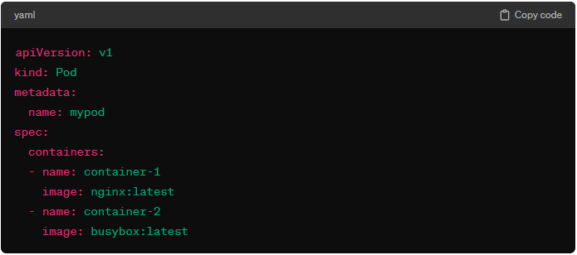

In this example, the Pod named "**mypod**" consists **of two containers:** "**container-1**" running the Nginx image and "**container-2**" running the **BusyBox** image. Both containers share the same **network namespace** and can communicate with each other.

Pods are a fundamental concept in Kubernetes and are used to deploy and manage applications. They provide a level of abstraction that simplifies the deployment and scaling of containerized workloads.

**Lifecycle of “Pod” in Kubernetes:**

The lifecycle of a **Pod** in Kubernetes involves several phases, from creation to termination. Understanding the Pod lifecycle is crucial for managing containerized applications effectively.

All containers in the pod have terminated successfully.

At least one of the containers defined in the pod is running.

Pod is pending phase until its containers are started.

Scheduled

Running

Pending

Failed

Unknown

The state of the pod is shown as unknown when the kubelet stop reporting to the API Server.

One or more containers in the pod has terminated unsuccessfully.

* **Here are the key phases in the lifecycle of a Pod:**
* **Pending:** The Pending phase occurs when a Pod is created, and the Kubernetes control plane is in the process of scheduling it to a suitable worker node. During this phase, the scheduler selects a node based on resource requirements, constraints, and other factors.
* **Container Creating:** In the Container Creating phase, the worker node is preparing to run the containers specified in the Pod's definition. This involves pulling container images from the container registry and setting up the necessary runtime environment.
* **Running:** Once the containers are successfully created and started, the Pod transitions to the Running phase. In this phase, the containers are actively running and serving the intended application or service. The Pod remains in the Running phase until it is terminated or encounters an issue.
* **Succeeded and Failed:** If the containers within the Pod complete their tasks successfully and exit, the Pod transitions to the Succeeded phase. On the other hand, if any container within the Pod fails to start or exits with an error, the Pod transitions to the Failed phase. In both cases, the Pod is considered to have completed its primary task.
* **Terminating:** The Terminating phase occurs when a decision is made to terminate the Pod. This can be initiated by the user, through a scaling operation, or due to an issue with the containers. During termination, the containers are gracefully stopped, and resources are released.
* **Terminate:** After successfully terminating, the Pod enters the Terminated phase. In this phase, the Pod's containers are no longer running, and it is removed from the worker node. The Pod may remain in the Terminated phase for a short period before being cleaned up.

**What is Minikube:**

Minikube is an open-source tool that facilitates the setup and management of a **single-node Kubernetes cluster on a local machine**. It is designed to enable developers to run Kubernetes clusters for development, testing, and learning purposes in a local environment. Minikube provides a lightweight and easy-to-use solution for getting started with Kubernetes without the need for a full-scale, multi-node cluster.

* **Key features and characteristics of Minikube include:**
  + **Local Kubernetes Cluster:** Minikube allows you to run a single-node Kubernetes cluster on your local machine. This is useful for developers who want to experiment with Kubernetes features, test applications, and develop in a Kubernetes environment without the need for a dedicated cloud or on-premises cluster.
  + **Easy Installation:** Minikube is easy to install and set up on various operating systems, including Linux, macOS, and Windows. It provides a simple command-line interface for starting, stopping, and managing the local Kubernetes cluster.
  + **Isolated Environment:** Minikube creates an isolated environment on your local machine, allowing you to experiment with Kubernetes without affecting other parts of your system. It achieves this by running a lightweight virtual machine using technologies like VirtualBox, VMware, or Hyper-V, depending on your platform.
  + **Support for Kubernetes Features:** Minikube supports a wide range of Kubernetes features, allowing developers to work with various components such as Pods, Services, Deployments, ConfigMaps, and more. It aims to provide a consistent Kubernetes experience, even in a single-node environment.
  + **Integration with Kubectl:** Minikube seamlessly integrates with the Kubernetes command-line tool, **kubectl,** this means that developers can use familiar **kubectl** commands to interact with and manage the local Minikube cluster.
  + **Addon Support:** Minikube supports addons that enable additional features and functionalities. Addons can include tools like dashboard, heapster (for resource monitoring), and others that enhance the capabilities of the local Kubernetes cluster.
  + **Multi-Cluster Support:** While Minikube is primarily designed for local development, it also supports the creation of multi-node clusters for more complex testing scenarios. This feature allows developers to simulate multi-node Kubernetes clusters on a single machine.

Minikube is a valuable tool for developers who want to learn, experiment, and develop applications using Kubernetes without the need for a large-scale production-like environment. It provides an easy and convenient way to get started with Kubernetes on a local machine.

**Kubectl:**

**Kubectl** is the official **command-line tool** for interacting with Kubernetes clusters. It serves as the primary means for users to communicate with and manage Kubernetes clusters. With **kubectl**, users can perform various operations, such as deploying applications, inspecting cluster resources, scaling applications, and troubleshooting issues within a Kubernetes environment. [**Kubectl Cheat Sheet**](https://kubernetes.io/pt-br/docs/reference/kubectl/cheatsheet/)

Overall, **kubectl** is a powerful and essential tool for administrators, developers, and operators working with Kubernetes. It provides a unified and consistent interface to interact with and manage Kubernetes clusters, helping users efficiently deploy and manage containerized applications.

**What is Pod.yaml file and what its roles and responsibilities?**

A **Pod** in Kubernetes is the smallest and simplest unit in the Kubernetes object model. It represents a single instance of a running process in a cluster and encapsulates one or more application containers. A **Pod** serves as the basic building block for deploying and running applications on Kubernetes.

A **pod.yaml** file is a YAML configuration file used to define the specifications of a Kubernetes Pod. It contains information about the Pod's desired state, such as the container images to run, volumes to mount, environment variables, networking configurations, and more. Here's a basic example of a **pod.yaml** file:

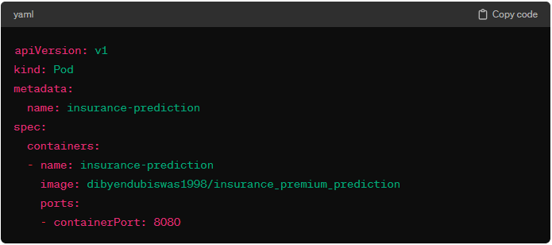

* **Let's break down the key components of a pod.yaml file:**
* **apiVersion:** Specifies the API version of the Kubernetes object being defined. In this case, it is **v1**, which is the core API version for Pods.
* **kind:** Specifies the type of Kubernetes object being defined. In this case, it is **Pod,** indicating that this YAML file is defining a Pod.
* **metadata:** Contains metadata about the Pod, such as its name and labels.
  + - **name:** Specifies the name of the Pod.
* **spec:** Defines the desired state of the Pod.
  + - **containers:** Specifies a list of containers to run within the Pod.
      * **name:** Specifies the name of the container.
      * **image:** Specifies the container image to use.
      * **ports:** Specifies the ports to expose in the container.
        + **containerPort:** Specifies that the container within the Pod will be listening on port 8080.

In summary, this **pod.yaml** file defines a Kubernetes Pod named "**insurance-prediction**" that contains a single container named "insurance-prediction." The container is running the Docker image "dibyendubiswas1998/insurance_premium_prediction," and it exposes port 8080. The Pod is a basic unit of deployment in Kubernetes, encapsulating the application and its runtime environment.

**Deployment in Kubernetes:**

A **Deployment** in Kubernetes is a higher-level abstraction that manages the desired state of application deployments, allowing you to declare the number of replicas, update strategy, and rollback mechanisms. It provides declarative updates for Pods and ReplicaSets, ensuring that the desired state specified by the user is maintained.

* **Key Features of Deployments:**
  + **Declarative Updates:** Define the desired state of your application (e.g., number of replicas, image version) and Kubernetes will manage the process of achieving and maintaining that state.
  + **Rolling Updates:** Deployments support rolling updates, allowing you to update your application version gradually, without downtime.
  + **Rollbacks:** If an update causes issues, you can easily rollback to a previous state.
  + **Scaling:** Easily scale the number of replicas up or down.
  + **Self-Healing:** Automatically replaces failed pods to maintain the desired number of replicas.
* **Benefits of Using Deployments:**

* + **Automated Updates:** Simplifies the process of updating applications with zero downtime through rolling updates.
  + **Version Control:** Allows rollbacks to previous versions in case of errors during updates.
  + **Scalability:** Easily scale applications up or down by changing the number of replicas.
  + **Self-Healing:** Ensures high availability by automatically replacing failed pods.
  + **Declarative Management:** Define the desired state of the application, and Kubernetes manages the rest.
* **Example of Deployment:**

Below is an example of **“deployment.yaml”** file:

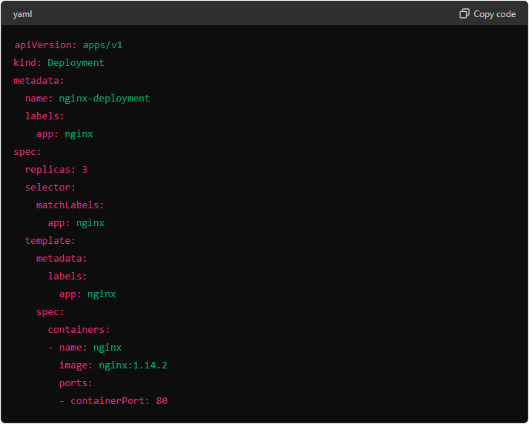

**Explanation of Tags in deployment.yaml:**

1. **apiVersion:**
   * Specifies the API version of the Kubernetes object.
   * **Example:** **‘**apiVersion: apps/v1**’**
2. **kind:** 
   * Defines the type of Kubernetes object.
   * **Example:** **‘**kind: Deployment**’**
3. **metadata:**
   * Contains metadata about the object, such as name, namespace, labels, and annotations.
   * **Example:**

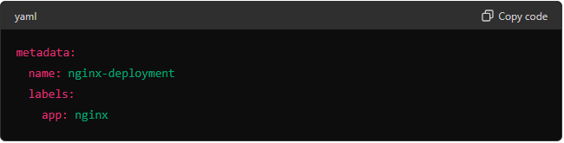

1. **spec:**
   * Defines the desired state of the Deployment.
   * **Example:**

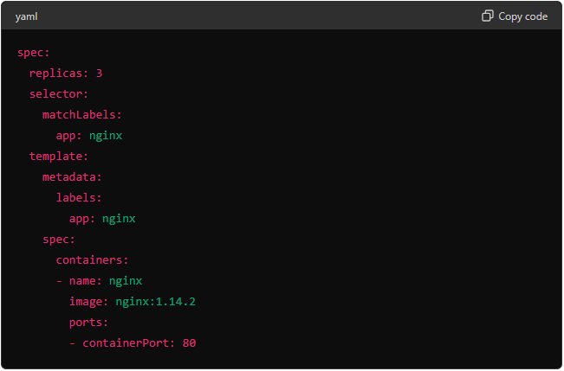

**Detailed Explanation of “spec” Tag:**

* **replica:** 
  + Specifies the number of desired pod replicas.
  + **Example:** **‘replica: 3’**
* **selector:** 
  + Defines how the Deployment finds which pods to manage based on their labels.
  + **Example:**

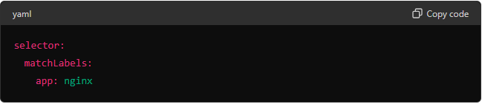

* **template:**
  + Describes the pods to be created by the Deployment, including the pod metadata and spec.
  + **template.metadata.labels:** Labels assigned to the pods created by the Deployment.
  + **template.spec:** Defines the specification for the pods, including containers, volumes, and other pod-level configurations.
  + **containers:** Defines the containers that run in the pod.
    - **name:** Name of the container.
    - **image:** The Docker image for the container.
    - **ports:** The ports exposed by the container.

Deployments in Kubernetes provide a powerful mechanism for managing the lifecycle of applications, allowing for declarative updates, scaling, and self-healing. By understanding the tags and configurations within a deployment.yaml file, you can efficiently manage your applications and leverage the full potential of Kubernetes.

**Labels and Selectors in deployment.yaml file:**

In Kubernetes, labels and selectors are key concepts used for organizing and selecting sets of objects within the system. They play a crucial role in grouping, identifying, and managing resources like Pods, Services, and Deployments.

* **metadata.labels:**

* + **Definition:** A label is a key-value pair associated with a Kubernetes object (e.g., Pod, Service, and Deployment). Labels are used to attach metadata or tags to objects.
  + **Example:**

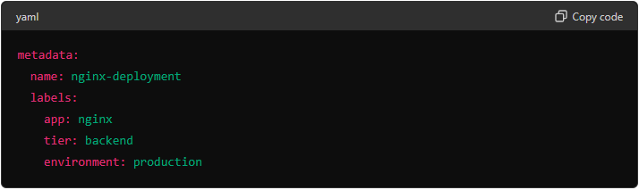

* + **Characteristics:**
* Labels are flexible and can be customized based on application-specific requirements.
* They do not have any predefined meaning; their interpretation is left to the user.
  + **Usages:** 
    - **Tagging Resources:** Labels are key-value pairs that tag Kubernetes resources such as pods, services, deployments, etc.
    - **Organization and Management:** Helps organize and manage resources by grouping them logically. For example, you might label all resources related to a specific application or environment (e.g., **‘app=nginx’**, **‘environment=production’**).
    - **Filtering and Selection:** Allows for efficient filtering and selection of resources using label selectors.
  + **Importance:** 
    - **Resource Identification:** Labels provide a way to identify and classify resources, making it easier to apply bulk operations, monitoring, and debugging.
    - **Flexibility:** Labels are flexible and can be applied to any Kubernetes resource, enabling a wide range of use cases from deployment strategies to monitoring and logging.
    - **Automation:** Automation tools and scripts can use labels to dynamically discover and manage resources.
* **spec.selectors:**
  + **Definition:** A selector is a query mechanism used to filter and select objects based on their labels. It allows users to identify a specific set of resources that share common characteristics.
  + **Example:**

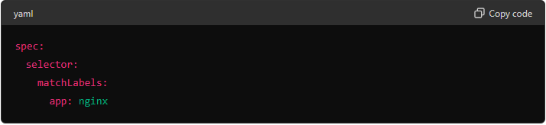

* + **Characteristics:**
* Selectors define criteria for selecting objects with matching labels.
* They enable the grouping of objects that serve a common purpose or share common attributes.
  + **Usages:** 
    - **Resource Selection:** Specifies how a controller (like Deployment or ReplicaSet) selects the set of pods it manages. It matches the pods based on their labels.
    - **Ensure Consistency:** Ensures that the controller manages only the pods with labels matching the selector, providing consistency and predictability in resource management.
  + **Importance:** 
    - **Controlled Resource Management:** By using selectors, Kubernetes controllers can manage the lifecycle of specific pods, ensuring that the desired state is maintained.
    - **Scalability:** Allows for scalable management of resources by clearly defining which pods should be managed by a given controller.
* **spec.template:**
  + **Example:**

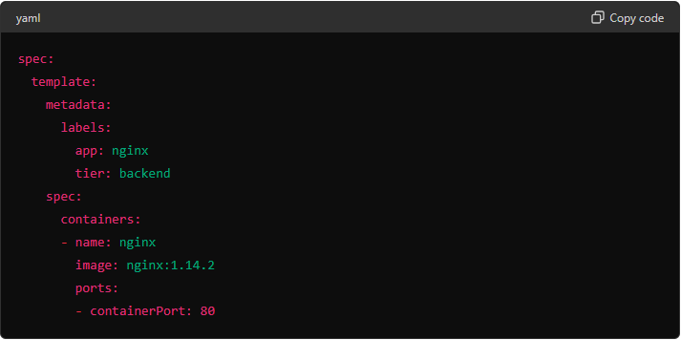

* + **Usages:** 
    - **Pod Definition:** Defines the pod specification that the controller uses to create new pods. It includes the metadata and spec for the pods.
    - **Blueprint for Replicas:** Acts as a blueprint for the creation of replicas, ensuring that all pods created by the controller have the same configuration.
  + **Importance:** 
    - **Uniformity:** Ensures that all replicas of a pod have a consistent configuration, including containers, volumes, labels, and other settings.
    - **Declarative Configuration:** Provides a declarative way to define the desired state of pods, making it easier to manage and update configurations.

**Difference between Containers, Pods and Deployment:**

In Kubernetes, containers, pods, and deployments are distinct but interconnected concepts that play key roles in managing and orchestrating applications.

* **Container:** 
  + **Definition:** A container is a lightweight, standalone, and executable software package that includes everything needed to run a piece of software, including the code, runtime, system tools, libraries, and settings.
  + **Kubernetes Roles:** Containers are the fundamental units of deployment in Kubernetes. Kubernetes uses container runtimes (such as Docker) to run containers within pods.
  + **Key Points:**
* Containers encapsulate an application and its dependencies.
* They provide consistency and portability across different environments.
* Each container runs in isolation and shares the host OS kernel.
* **Pod:**
* **Definition:** A pod is the smallest deployable unit in Kubernetes, representing a group of one or more containers that share the same network namespace, storage, and have the capability to communicate with each other using localhost.
* **Kubernetes Roles:** Pods are the basic building blocks for deploying applications in Kubernetes. They provide a layer of abstraction over containers, allowing for multiple containers to be co-located and share resources.
* **Key Points:**
* Pods are the scheduling unit in Kubernetes, representing a collocated group of containers.
* Containers within the same pod share the same IP address, port space, and storage volumes.
* Pods provide a way to manage the co-location and co-scheduling of tightly coupled application components.
* **Deployment:**
* **Definition:** A deployment is a higher-level Kubernetes resource that enables declarative updates to applications. It allows you to describe the desired state of the application and Kubernetes takes care of making the necessary changes to achieve that state.
* **Kubernetes Roles:** Deployments are used to manage the deployment and scaling of applications. They provide mechanisms for rolling updates, rollbacks, and scaling operations.
* **Key Points:**
* Deployments abstract away the underlying complexity of managing pods and containers.
* They ensure that a specified number of replicas of the application are running and handle updates without downtime.
* Deployments can be used to scale applications horizontally by adjusting the number of replicas.

In practice, you typically define a deployment to manage the desired state of your application, and the deployment controller takes care of creating and updating the underlying pods and containers based on your specifications. This abstraction allows for easier management, scaling, and maintenance of containerized applications in Kubernetes.

**What is Replica set controller & What is Replica or Replica Set.**

In Kubernetes, a ReplicaSet is a controller that ensures a specified number of replica pods are running at all times. It is part of the broader category of controllers in Kubernetes, which includes controllers like Deployments and StatefulSets.

* **ReplicaSet Controller:**
* **Definition:** A ReplicaSet controller is responsible for maintaining a stable set (a specified number) of replica pods running at all times. If the actual number of pods deviates from the desired state, the ReplicaSet controller takes corrective actions to reconcile the difference.
* **Purpose:** The primary purpose of a ReplicaSet is to provide high availability and fault tolerance by ensuring that a specified number of identical pod replicas are running to handle the application's load.
* **Characteristics:**
* **Selectors:** A ReplicaSet uses selectors to identify the pods it should manage. These selectors are based on labels assigned to the pods.
* **Pad Template:** The ReplicaSet defines a template for creating pods, and it ensures that the actual running pods match this template.
* **Scaling:** The ReplicaSet can scale the number of pods up or down based on the desired replica count.
* **Summary:**
* Manages a set of identical pod replicas.
* Ensures the desired number of replicas are running.
* Uses selectors and pod templates to define and identify pods.
* **Replica:**
  + **Definition:** In the context of a ReplicaSet, a replica refers to an instance of a pod that is created and managed by the ReplicaSet controller.
  + **Purpose:** Replicas provide redundancy and scalability for the application. If one pod fails or becomes unhealthy, the ReplicaSet controller replaces it with a new replica, maintaining the desired number of replicas.
  + **Characteristics:**
* **Identical:** All replicas created by a ReplicaSet are identical, as they are based on the same pod template.
* **Load Balancing:** Replicas distribute the incoming traffic, contributing to load balancing for the application.
* **Summary:**
* An instance of a pod managed by a ReplicaSet.
* Provides redundancy, fault tolerance, and scalability for the application.

**Kubernetes Controller:**

In Kubernetes, a controller is a core concept responsible for managing the desired state of a particular resource and ensuring that the current state converges to the desired state. Controllers play a crucial role in maintaining the health, availability, and desired configurations of applications and resources within a Kubernetes cluster.

**Difference between Deployment and Replica Sets in K8s.**

In Kubernetes, Deployments and ReplicaSets are both resources used for managing and scaling applications, but they serve different purposes and offer distinct features.

* **Deployment:**
* Provides a higher-level abstraction for application deployment and updates.
* Supports declarative updates, rolling updates, and rollbacks.
* Dynamically updates pod templates.
* Focused on managing the application lifecycle.
* **ReplicaSets:**
* Primarily focused on ensuring a specified number of identical pod replicas are running.
* Uses selectors to identify and manage pods.
* Handles pod restarts and scaling operations.
* Often managed by higher-level controllers like Deployments.

In practice, Deployments are often used instead of directly managing ReplicaSets because they offer more advanced features for managing application updates and rollbacks. Deployments use ReplicaSets under the hood to achieve the desired state.

**How to create one deployment.yaml file using multiple docker images:**

In Kubernetes, a Deployment is typically associated with a single container image. However, if you need to deploy multiple containers (each with a different Docker image) within the same pod, you can use an initiative called multi-container pods. Each container in a multi-container pod runs in the same network namespace and can communicate with each other using **localhost**.

**Here's an example of a “deployment.yaml” file that deploys a pod with two containers, each using a different Docker image:**

* The Deployment is named **“multi-container-deployment”**.
* It specifies that there should be one replica of the pod.
* The pod selector uses the label **“app: multi-container-app”**.
* The template for the pod defines two containers (**“container-1”** and **“container-2”**).
* Each container is associated with a different Docker image (**“your-docker-image-1:tag”** and **“your-docker-image-2:tag”**).
* Both containers expose a port (**“8000”** for **“container-1”** and (**“8081”** for **“container-2”**).

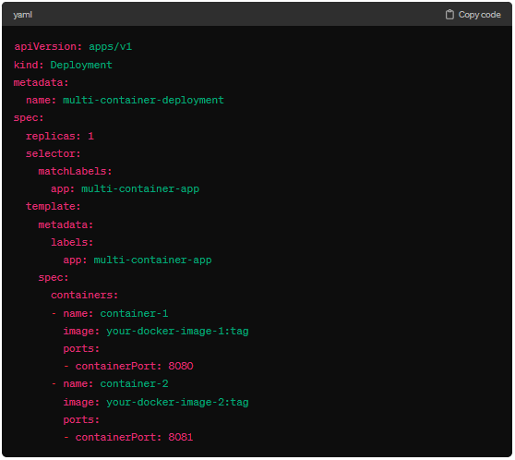

Save this YAML file and apply it using the **“kubectl apply”** command:

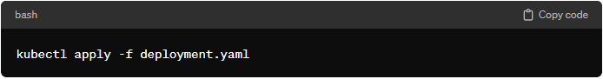

This creates a Deployment that manages a pod with two containers running different Docker images. Keep in mind that the containers in a multi-container pod share the same network namespace, which allows them to communicate with each other over **localhost**. Communication between containers in the same pod is often achieved using inter-process communication (IPC) mechanisms or shared volumes.

**Zero-Downtime Deployment in Kubernetes:**

Zero-downtime deployment in Kubernetes refers to a deployment strategy that aims to update or roll out a new version of an application without causing any interruption or downtime in the service. The goal is to seamlessly transition from the old version to the new version, ensuring continuous availability for end-users. This approach is crucial for maintaining a high level of service reliability and user satisfaction during application updates or changes.

**Service in Kubernetes. Why we create this service and what is importance of service.**

In Kubernetes, a Service is an abstraction that defines a logical set of pods and a policy by which to access them. Services enable communication and discovery between different parts of an application within a Kubernetes cluster. They play a crucial role in providing network connectivity, load balancing, and service discovery, contributing to the scalability and reliability of distributed applications.

* **Key aspects and Importance of Services in Kubernetes:**
* **Pod Discovery:** Services provide a stable endpoint (IP address and port) that represents a set of pods with a common label. This stable endpoint allows other components of the application to discover and communicate with pods, even as they scale up or down.
* **Load Balancing:** Services automatically distribute incoming network traffic across the pods that belong to the service. This load balancing ensures that no single pod is overwhelmed with traffic, and it contributes to the overall availability and reliability of the application.
* **Internal DNS Resolution:** Kubernetes provides a DNS service (kube-dns or CoreDNS) that automatically creates DNS records for each Service. This enables other pods within the cluster to access services using the service name rather than the IP address, providing a more human-readable and abstract way to reference services.
* **Service Types:** Kubernetes supports different types of services to accommodate various use cases:
  + - **ClusterIP:** The default type. The service is only accessible within the cluster.
    - **NodePort:** Exposes the service on each node's IP at a static port. It allows external access to the service.
    - **LoadBalancer:** Exposes the service externally using a cloud provider's load balancer.
    - **ExternalName:** Redirects the service to a user-specified DNS name.
* **Service Discovery:** Services facilitate service discovery by providing a well-known and consistent way to access the components of an application. This is crucial in microservices architectures, where services need to locate and communicate with each other dynamically.
* **Session Affinity (Sticky Sessions):** Services can be configured to use session affinity, directing client requests to the same pod in a set of pods. This is useful for applications that require persistence or for scenarios where sticky sessions are needed.
* **Example of a Simple Services Definition:**

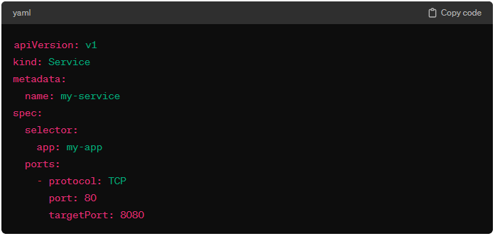

**In this example:**

* The service is named **my-service.**
* It selects pods with the label **app: my-app.**
* The service listens on port **80** and forwards traffic to pods on port **8000**.

**Service Discovery in K8s:**

Service discovery in Kubernetes refers to the mechanism by which applications or services within a Kubernetes cluster can dynamically find and connect to each other. In a microservices architecture, where applications are composed of multiple loosely coupled services, service discovery becomes essential for maintaining connectivity and enabling communication between these services.

* **Key aspects of service discovery in Kubernetes include:**
* **Dynamic IP Assignments:** Pods in Kubernetes are assigned dynamic IP addresses, and these addresses can change as pods are created, scaled, or rescheduled. Service discovery allows other components to find the current IP addresses of the pods associated with a particular service.
* **Stable Service Endpoints:** Kubernetes Services provide stable endpoints (IP addresses and ports) that represent a set of pods. These endpoints are constant and abstract away the underlying changes in the individual pod IP addresses. Service discovery allows other services to connect to these stable endpoints.
* **DNS Resolution:** Kubernetes provides a built-in DNS service (such as kube-dns or CoreDNS) that automatically creates DNS records for each Service. This DNS resolution allows services to be accessed using their service names rather than hardcoding IP addresses. For example, a service named **my-service** can be accessed at **“my-service.namespace.svc.cluster.local”**.
* **Load Balancing:** Services in Kubernetes automatically distribute incoming traffic across the pods associated with the service. This load balancing ensures that requests are evenly distributed among healthy pods, contributing to high availability and fault tolerance.
* **Service Labels and Selectors:** Labels and selectors play a crucial role in service discovery. Services are associated with pods based on labels. Other components can discover and connect to a service by querying for pods with specific labels. Labels and selectors provide a flexible way to group and select pods.
* **External Access:** Kubernetes Services support various types, including ClusterIP (accessible only within the cluster), NodePort (accessible externally on each node), and LoadBalancer (exposing services externally using a cloud provider's load balancer). Service discovery helps external clients access services based on their type and configuration.
* **Example Scenario:**

Let's consider an example where **Service A** needs to communicate with **Service B** within a Kubernetes cluster:

* **Service B Registration:** Service B registers itself by creating a Kubernetes Service with a specific label (e.g., **“app: service-b”**).

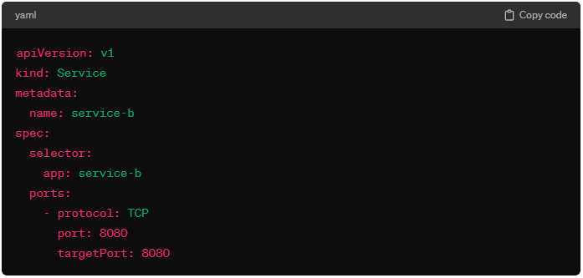

* **Service A Discovery:** Service A, which needs to communicate with Service B, queries the Kubernetes DNS service or uses Kubernetes client libraries to discover the IP addresses of pods with the label **“app:service-b”**.
* **Connection to Service B:** Service A connects to the stable service endpoint provided by Service B (e.g., **“service-b.namespace.svc.cluster.local:8000”**), ensuring that the connection remains stable despite changes in the individual pod IP addresses.

In summary, service discovery in Kubernetes simplifies the process of locating and connecting to other services within the cluster, allowing for dynamic and scalable communication in a microservices environment.

**Types of Kubernetes Services (Cluster IP, Node Port Mode, Load Balancer). When to choose Cluster IP, Node Port Mode, and Load Balancer. Explain with the help of an example.**

In Kubernetes, there are several types of services that provide different ways to expose applications within and outside the cluster. The three main types are ClusterIP, NodePort, and LoadBalancer. The choice of service type depends on the use case and requirements of your application.

* **ClusterIP:**
* **Use Cases:** Use ClusterIP when you want to expose a service internally within the cluster. This service type creates a virtual IP address that is only accessible from within the cluster.
* **Example:** Suppose you have a backend service that should only be accessed by other services within the same Kubernetes cluster. You can use ClusterIP to create an internal virtual IP address for this service.

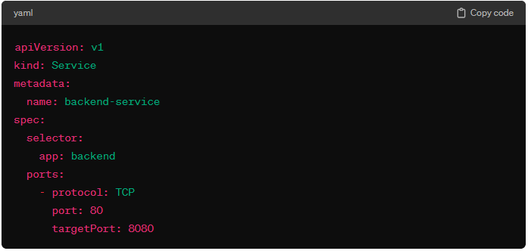

* **NodePort:**
* **Use Cases:** Use NodePort when you want to expose a service on a specific port on each node in the cluster. This allows external access to the service by connecting to any node's IP address on the specified port.
* **Example:** Consider a scenario where you have a web application, and you want to make it accessible externally on a specific port. NodePort can be used for this purpose.

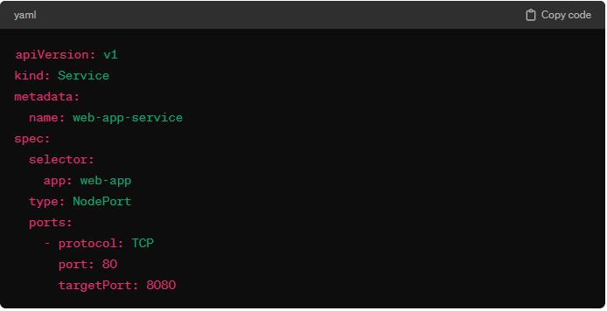

After creating the service, you can access the web application externally using any node's IP address and the assigned NodePort.

* **LoadBalancer:**
* **Use Cases:** Use LoadBalancer when you want to expose a service externally and automatically provision an external load balancer (if supported by the cloud provider).
* **Example:** Suppose you have a microservice that needs to be accessed by clients outside the Kubernetes cluster, and you want to leverage a cloud provider's load balancer for better scalability and reliability.

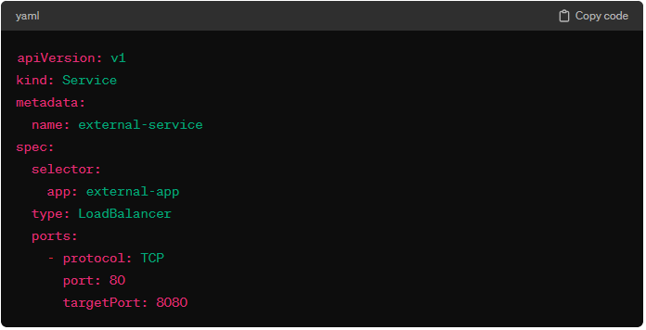

When you create this service, the cloud provider (if supported) will automatically provision an external load balancer with a public IP address. Clients can then access the service using this public IP address.

* **ClusterIP:** Internal service, accessible only within the cluster.
* **NodePort:** Exposes the service on a specific port on each node for external access.
* **LoadBalancer:** Exposes the service externally using a cloud provider's load balancer.

Choose the appropriate service type based on your application's requirements. In many cases, applications may use a combination of these service types to meet both internal and external access needs.

**Stage 1: Interview Questions:**

* **Q1: What is ideal size of pods (number of pods) in an application?**

The ideal size of pods (number of pods) for an application in Kubernetes depends on several factors, including the application's requirements, the infrastructure available, and the desired performance, scalability, and reliability. There is no one-size-fits-all answer, but here are some key considerations and general guidelines to help determine the appropriate number of pods for your application:

* **Factor Consider:** 
  1. **Application Load and Performance Requirements:**
     + **Current Load:** Understand the current traffic load and resource requirements of your application.
     + **Peak Load:** Plan for peak traffic loads to ensure your application can handle spikes in usage.
     + **Performance Metrics:** Monitor metrics such as CPU usage, memory usage, response times, and throughput.
  2. **Resource Availability:** 
     + **Node Resources:** Ensure your nodes have sufficient CPU, memory, and storage resources to handle the pods.
     + **Pod Resource Request and Limits:** Set appropriate resource requests and limits for each pod to ensure efficient resource utilization and avoid contention.
  3. **Scalability and Elasticity:** 
     + **Horizontal Scaling:** Determine how easily your application can scale horizontally by adding more pods.
     + **Autoscaling:** Utilize Kubernetes Horizontal Pod Autoscaler (HPA) to automatically adjust the number of pods based on observed metrics (e.g., CPU usage, memory usage, and custom metrics).
  4. **Reliability and High Availability:** 
     + **Redundancy:** Ensure enough pods are running to provide redundancy in case of pod or node failures.
     + **Disruption Budget:** Define PodDisruptionBudgets (PDBs) to limit the number of pods that can be disrupted during maintenance or upgrades.
  5. **Deployment Strategy:** 
     + **Rolling Updates:** Plan for rolling updates where new pods replace old ones without downtime.
     + **Canary Deployments:** Use canary deployments to gradually introduce new versions of the application and reduce risk.
  6. **Network Latency:** 
     + **Pod Distribution:** Distribute pods across different nodes and availability zones to minimize latency and improve fault tolerance.
     + **Service Load Balancing:** Ensure the service load balancing strategy efficiently distributes traffic to the pods.
* **Example Scenario:** 
  1. **Small Web Application:** 
     + Start with 2-3 pods to ensure basic redundancy and high availability.
     + Monitor traffic and resource usage, and scale up if needed.
  2. **Medium-Sized Microservices Application:** 
     + For each microservices, start with 3-5 pods.
     + Use HPA to scale pods based on CPU or memory usage.
  3. **Large-Scale Application:** 
     + Start with 10-20 pods for critical components.
     + Implement HPA and possibly cluster Autoscaling to handle dynamic scaling requirements.
     + Ensure pods are distributed across multiple nodes and availability zones for fault tolerance.

The ideal number of pods for an application varies based on multiple factors such as load, resource availability, and scaling requirements. Starting with a small number of pods and using Kubernetes' autoscaling capabilities allows you to adjust dynamically based on real-time performance metrics, ensuring optimal resource utilization, performance, and high availability.

* **Q2: What happen if there is no Service in Kubernetes? And what kind of problems solved by “Kubernetes Service”?**

**Without a Kubernetes Service:**

* **Direct Pod Communication:** Without a Service, you would need to communicate directly with Pods using their IP addresses. This is impractical because Pod IPs can change if Pods are restarted or rescheduled.
* **Dynamic Scaling Issues:** If the number of Pods changes due to scaling operations, manually updating the list of IPs becomes cumbersome and error-prone.
* **Load Balancing:** There would be no built-in mechanism for distributing traffic among multiple instances of a Pod.

**Problems Solved by Kubernetes Service:**

* **Stable Network Endpoint:** Services provide a stable IP address and DNS name that remain constant regardless of changes to the underlying Pods.
* **Load Balancing:** Services distribute network traffic across multiple Pods, ensuring that no single Pod becomes a bottleneck.
* **Service Discovery:** Services make it easy for Pods to discover and communicate with each other. This is essential for microservices architectures where different services need to interact.
* **Isolation and Access Control:** Services allow you to control which Pods can communicate with each other, providing network segmentation and security.
* **Q3: What is difference between Docker and Kubernetes?**
* **Q4: What are the main component of Kubernetes Architecture?**
* **Q5: What are the main difference between Docker Swarm and Kubernetes?**

**Docker Container:**

* **Definition:** A Docker container is a lightweight, standalone, executable package that includes everything needed to run a piece of software, including the code, runtime, libraries, and system tools.
* **Isolation:** Containers provide process and file system isolation using namespaces and cgroups.
* **Lifecycle:** Managed by Docker Engine or container runtime.
* **Networking:** Each container typically gets its own IP address within a Docker network.

**Kubernetes Pod:**

* **Definition:** A Pod is the smallest deployable unit in Kubernetes and represents one or more Docker containers that are tightly coupled. They share the same network namespace, IP address, and storage volumes.
* **Composition:** A Pod can contain one or multiple containers. These containers share resources and can communicate over the localhost.
* **Lifecycle:** Managed by Kubernetes. Kubernetes schedules, runs, and monitors Pods.
* **Networking:** Pods within the same node can communicate with each other using localhost. Pods across different nodes communicate using a flat network provided by Kubernetes.
* **Q6: What is difference between “Docker Container” and “Kubernetes Pod”?**

**Namespace:**

* **Definition:** A namespace is a virtual cluster within a Kubernetes cluster, used to isolate and manage resources.
* **Purpose:** Namespaces allow you to divide cluster resources between multiple users or applications, creating boundaries that help in managing access and resource allocation.
* **Use Cases:** 
  + **Resource Segmentation:** Separate environments (development, testing, production) within the same cluster.
  + **Access Control:** Apply Role-Based Access Control (RBAC) policies to restrict access to resources within specific namespaces.
  + **Resource Quotes:** Limit resource usage per namespace to ensure fair resource distribution.
* **Example:** You might create namespaces like **‘dev’**, **‘test’**, and **‘prod’** to isolate the environments for different stages of application development.
* **Q7: What is “namespace” in Kubernetes?**

**NodePort:**

* **Definition:** Exposes a service on each Node’s IP address at a static port (the NodePort).
* **Access:** You can access the service using **‘NodeIP: NodePort’**.
* **Use Cases:** Suitable for simple, internal access within a cluster or for exposing services in development environments.
* **Drawbacks:** Not suitable for production environments as it doesn’t provide external load balancing or a single entry point.

**LoadBalancer:**

* **Definition:** Exposes the service externally using a cloud provider’s load balancer.
* **Access:** Provides a single IP address (external IP) that forwards traffic to the service, automatically handling load balancing.
* **Use Cases:** Ideal for production environments where you need to expose services to the internet with automatic load balancing.
* **Features:** Offers more advanced features like SSL termination, health checks, and better scalability compared to NodePort.
* **Q8: What is role of “Kube-Proxy”?**
* **Q9: What are the different types of services within Kubernetes?**
* **Q10: What is the difference between NodePort and LoadBalancer?**
* **Q11: What is the roles of “Kubelet”?**

**Kubelet Roles:**

* **Pod Management:** The kubelet is responsible for ensuring that containers described in PodSpecs are running and healthy.
* **Node Agent:** It runs on each node and communicates with the Kubernetes control plane to manage the lifecycle of Pods assigned to that node.
* **Health Monitoring:** It periodically checks the health of containers and restarts them if they fail.
* **Reporting:** The kubelet reports the status of nodes and Pods back to the control plane, ensuring that the cluster state is up-to-date.
* **Resource Management:** It monitors and enforces resource limits and requests for CPU and memory.
* **Q12: Day to Day activities on Kubernetes.**

**Day-to-Day Activities:**

* **Deployment Management:** Deploying new applications and updates using Deployments, StatefulSets, and DaemonSets.
* **Monitoring and Logging:** Setting up and maintaining monitoring and logging systems (e.g., **Prometheus**, **Grafana**, **ELK stack**) to track cluster health and application performance.
* **Scaling:** Managing horizontal and vertical scaling of applications to handle varying loads.
* **Networking:** Configuring Services, Ingress controllers, and network policies to ensure proper communication and security.
* **Security:** Implementing RBAC, Network Policies, and Pod Security Policies to secure the cluster and applications.
* **Troubleshooting:** Debugging issues with Pods, Services, and the cluster itself. This includes using tools like **‘kubelet logs’**, **‘kubelet describe’**, and **‘kubelet exec’**.
* **Backup and Restore:** Implementing backup strategies for cluster state and persistent storage.
* **Resource Management:** Monitoring resource usage and managing quotas to ensure fair distribution and efficient utilization of cluster resources.
* **CI/CD Integration:** Automating deployment pipelines using tools like Jenkins, GitHub Actions, or GitLab CI/CD.
* **Cluster Maintenance:** Performing upgrades, patching nodes, and managing cluster lifecycle.

**Ingress in Kubernetes:**

**Ingress** is a Kubernetes resource that manages external access to services within a Kubernetes cluster, typically HTTP and HTTPS traffic. It acts as a reverse proxy, routing traffic to various services based on the rules defined in the Ingress resource.

* **Why Ingress is required?**

In Kubernetes, services are typically exposed using different types of services like **ClusterIP**, **NodePort**, and **LoadBalancer**. However, these services have limitations when it comes to managing and routing HTTP/S traffic:

* **ClusterIP** is only accessible within the cluster.
* **NodePort** exposes services on static ports across all nodes, which is not ideal for production environments.
* **LoadBalancer** creates individual load balancers for each service, which can be costly and inefficient.

Ingress solves these problems by providing a single point of entry for HTTP/S traffic and offering more flexible routing capabilities.

* **Problems Solved by Ingress:**
  + **Centralized Management:** Ingress allows you to manage routing rules centrally, reducing complexity.
  + **Efficient Resource Usages:** Instead of creating multiple external load balancers, Ingress can route traffic through a single load balancer, reducing costs.
  + **Flexible Routing:** Ingress supports advanced routing rules, such as path-based routing and host-based routing, making it easier to direct traffic to the appropriate services.
  + **TLS Termination:** Ingress can handle SSL/TLS termination, offloading this task from your services and simplifying certificate management.
* **Features of Ingress:** 
  + **Path-Based Routing:** Route traffic based on the URL path, allowing you to direct requests to different services based on the request path.
  + **Host-Based Routing:** Route traffic based on the host header, enabling different services to be served from the same IP address based on the hostname.
  + **TLS/SSL Termination:** Handle SSL/TLS termination, simplifying the management of certificates and enabling HTTPS traffic.
  + **Load Balancer:** Distribute incoming traffic across multiple backend services, ensuring high availability and reliability.
  + **Custom Rules and Annotations:** Extend functionality with custom rules and annotations for specific ingress controllers like NGINX or Traefik.
* **Importance of Ingress:**
  + **Simple Traffic Management:** Centralizes and simplifies the management of incoming traffic, reducing the complexity of service exposure.
  + **Cost-Effective:** Reduces the need for multiple external load balancers, lowering costs and improving resource utilization.
  + **Enhanced Security:** By handling SSL/TLS termination, Ingress improves the security of your services.
  + **Scalability:** Supports high traffic volumes and can scale with your application's needs.
  + **Flexibility:** Offers advanced routing capabilities, enabling more flexible and efficient traffic management.
* **Example of Using Ingress:**

Consider an e-commerce application with the following services:

* **Frontend-service:** Handles the web interface.
* **Backend-service:** Handles API requests.
* **Admin-service:** Manages administrative tasks.

**You can configure an Ingress resource to route traffic appropriately:**

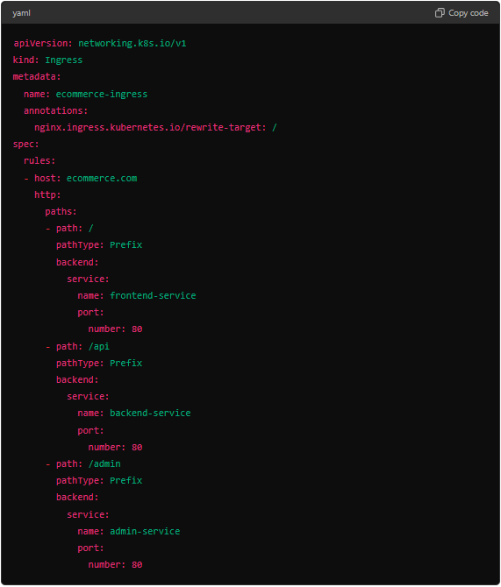

In this example, requests to **‘http://ecommerce.com/’** go to the frontend service, requests to **‘http://ecommerce.com/api’** go to the backend service, and requests to **‘http://ecommerce/admin’** go to the admin service. This setup centralizes traffic management, simplifies service exposure, and enhances scalability and security.

* **Ingress Resources:**

An Ingress resource is a set of rules that allows inbound connections to reach the cluster services. It defines how to route external HTTP/S traffic to services within the Kubernetes cluster based on specified rules, such as URL paths or hostnames.

* **Ingress Controller:**

An Ingress controller is a specialized load balancer for managing Ingress resources. It watches the Kubernetes API server for changes to Ingress resources and configures the corresponding load balancer to route traffic according to the Ingress rules.

* **Example of Ingress Resources and Ingress Controller:**

Let's consider a scenario where we have two services, **‘web-service’** and **‘api-service’**, running in our Kubernetes cluster. We want to route traffic to these services based on URL paths:

* Request to **‘http://example.com/’** should go to **‘web-service’**.
* Request to **‘http://example.com/api’** should go to **‘api-service’**.

**First, we define an Ingress resource:**

**Ingress Resources:**

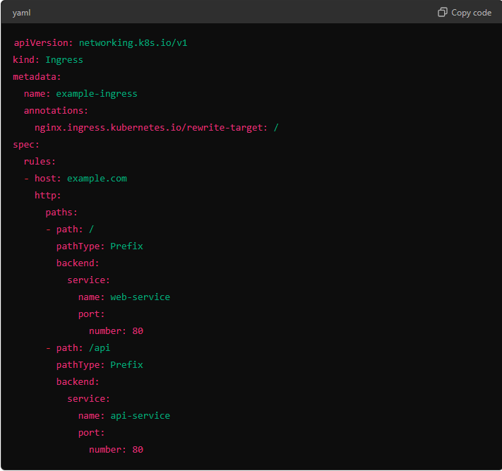

Next, we need an Ingress controller to process this Ingress resource. One popular Ingress controller is the NGINX Ingress Controller.

**Ingress Controller:**

The NGINX Ingress Controller is a daemon that runs alongside the Ingress resource. It configures the NGINX load balancer according to the rules defined in the Ingress resource.

* **Best Load Balancer Available in the Market:**
* **NGINX**
* **HAPROXY**
* **F5 Networks**
* **AWS Elastic Load Balancer (ELB)**
* **Google Load Balancer (GCLB)**
* **Microsoft Azure Load Balancer**
* **Different types of Ingress Controllers and their Features:**
* **NGINX Ingress Controller:**
  + **Features:** 
    - Supports HTTP, HTTPS, TCP, and UDP.
    - TLS termination and SNI support.
    - URL path-based routing.
    - Request and response rewriting.
    - Traffic mirroring and canary releases.
    - WebSocket and gRPC support.
* **Traefik Ingress Controller:** 
  + **Features:** 
    - Dynamic configuration updates.
    - HTTPS with Let's Encrypt support.
    - WebSocket, HTTP/2, and gRPC support.
    - Traffic mirroring.
    - Path and host-based routing.
    - Metrics and tracing integration.
* **Kong Ingress Controller:** 
  + **Features:** 
    - API Gateway capabilities.
    - Authentication, rate limiting, and logging.
    - gRPC, WebSocket, and HTTP/2 support.
    - Load balancing and health checks.
    - Plugin support for custom functionality.
* **Contour Ingress Controller:**
* **Features:** 
  + Built on Envoy proxy.
  + Advanced load balancing and routing.
  + Automatic TLS certificate management with Cert-Manager.
  + Rate limiting and traffic shaping.
  + gRPC and HTTP/2 support.
* **Istio Ingress Gateway:** 
  + **Features:** 
    - Comprehensive traffic management.
    - Security with mutual TLS and fine-grained RBA.
    - Observability with detailed telemetry.
    - Policy enforcement.
    - Resiliency features like retries, timeouts, and circuit breakers.

Ingress provides a powerful and flexible way to manage external access to your Kubernetes services, enabling centralized routing, efficient resource usage, enhanced security, and scalability.